

Aleea Alexandru nr. 38
Sector 1, RO-011824, Bucharest
Phone: 00 40317 00 691
tps@icr.ro

GRANT APPLICATION FORM

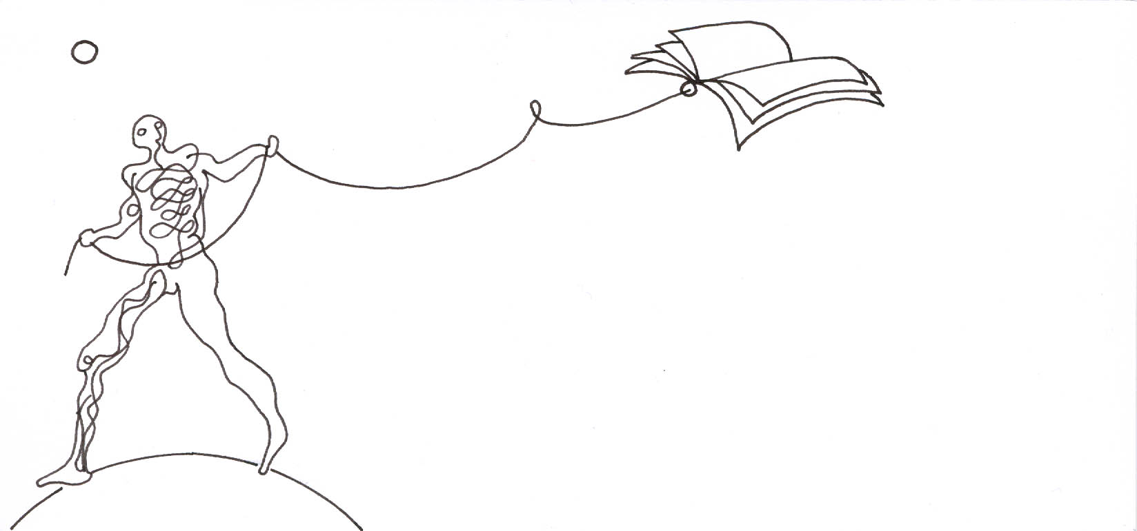

TPS - Translation and Publication Support Programme

«2019 - 2020»

*This application form shall be completed in English. All information shall be typed in. No fields are to be left empty. The application form, wet-signed by all parties, shall be submitted, by post, alongside the supporting items required per the programme guidelines.
Application no.
(to be completed upon registration)

A. INFORMATION ON THE APPLICANT INSTITUTION

1.1 Name of the organisation and acronym/abbreviation:

1.2 Legal status: Private □ Public □

1.3 Registration number:

1.4 Date of establishment:

1.5 Address: Street:
Postcode:
Town/city:
Country:

  - Tel. (including country and area codes):

Fax (including country and area codes):

1.7 E-mail:

1.8 Website:

1.9 Permanent staff employed by the organisation (number):

1. 10 Number of titles published per year:

1. 11 Average print-run for a published title:

1.12 Legal representative (person authorised to sign an agreement with the Romanian Cultural Institute):
Name:
First Name:
Position:

1.13 Contact person/publisher:
Name:
First Name:
Position:

1.14 Person responsible for financial matters:
Name:
First Name:
Position:

1.15 A short company profile:

B. INFORMATION ABOUT THE BOOK TO BE PUBLISHED

  - ORIGINAL WORK TO BE TRANSLATED

Title:

Author(s):

Nationality of author:

Literary genre:

Date of first publication:

Place of first publication:

Original language:

Brief synopsis of the work in English:

  - TRANSLATION

Date of transfer of translation rights:

Proposed target language :

Has the work already been translated into this language?

YES 

NO 

Will the translated work be published in a bilingual edition?

YES 

NO 

1.18 TRANSLATOR(S)

Name:

Nationality:

Address:

Selection of translated works:

1.19 OPERATION COSTS

Number of pages:

Total number of characters per page:

Remuneration of translator per page (in Euro):

Total cost of translation (in Euro):

Production costs (in Euro):

- Printing costs:
- Layout:
- Proof-reading:
- Editing:
- Binding:
- Design:

Total production costs:

Amount requested from The Romanian Cultural Institute (in Euro)

- up to 100% of the translation costs (not exceeding 17 000 Euro):

- up to 50% of the production costs not exceeding 3 000 Euro, or
max. 9 000 Euro for applications requesting only production costs:

Total amount:

Copyright costs (in Euro):

Promotion costs (in Euro):

Distribution costs (in Euro):

Planned retail price of the translated work (in Euro):

Planned print-run of the translated work:

Scheduled date of publication (month and year):

Have you received or applied for another grant for the translation of this work? If so, please indicate the name of the organisation to which you applied, and the amount requested (in Euro):

Have you received or applied for a grant for the publication of this work? If so, please indicate the name of the organisation to which you applied, and the amount requested (in Euro):

Date:

Name and SIGNATURE of the publisher:

Name and SIGNATURE of the translator(s):

C. DECLARATION

The following declaration must be signed by the person legally authorised to commit the applicant organisation/beneficiary

This is to certify that the submitted information is true and correct and that the applicant organization is not in any of the following situations:
- being bankrupt or being wound up, having the affairs administered by the courts, having entered into an arrangement with creditors, having suspended business activities, being the subject of proceedings concerning those matters, or being in any analogous situation arising from a similar procedure provided for in national legislation or regulations;
- having been convicted of an offence concerning professional conduct by a judgement which has the force of res judicata (i.e., against which no appeal is possible);
- being guilty of grave professional misconduct proven by any means which the contracting authority can justify;
- having not fulfilled obligations relating to the payment of social security contributions or the payment of taxes in accordance with the legal provisions of the country in which is established.

By signing this declaration, I hereby confirm that I have read, understood and will abide by the terms of the Translation and Publication Support (TPS) Programme guidelines and, should the application be selected, I hereby undertake to deliver the operation according to the details of the present application.

Name:

Position within the applicant organisation:

Date:

Signature:

Official stamp (if available):

